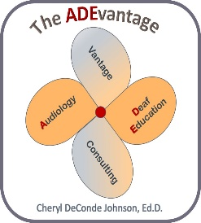

PO Box 918

**Cheryl DeConde Johnson, Ed.D.**

**The ADEvantage**

**Audiology Deaf Education vantage consultating**

Leadville, CO 80461

Phone: 970-590-5500

email: [cdj1951@gmail.com](mailto:cdj1951@gmail.com)

[www.ADEvantage.com](http://www.ADEvantage.com)

March 20, 2019

Educational Audiology Association

It is my privilege and honor to write this letter of support for the nomination of Dr. Donna Smiley as the 2019 recipient of the Educational Audiology Association’s Frederick Berg Award. Dr. Smiley has received numerous awards and accolades throughout her career that have recognized her accomplishments in not only educational audiology but other related aspects of the audiology profession. This award specifically recognizes Dr. Smiley’s committment to the important role of educational audiology services in the education of children who are deaf or hard of hearing.

Dr. Smiley has served in both educational and clinical audiology capacities as well as faculty appointments at the Unversity of Tennessee, University of Centeral Arkansas, and University of Arkansas. At present, she is the Coordinator and Supervisor of the EARS (Educational Audiology Resources for Schools) Program that provides contracted educational audiology and speech-language pathology services to early childhood programs and school districts in Arkansas. Dr. Smiley’s tenacity to find a viable path to provide educational audiology services to school districts is remarkable. Through her audiology position at Arkansas Children’s Hospital, she has built a contract model starting with one school district that has expanded to multiple early childhood programs and school districts, that has added specialized speech-language pathology services, and that has increased the number of audiologists and speech-language pathologists who are working in schools through the EARS program.

In addition to the EARS program, Dr. Smiley has a long history of involvement with Arkansas state level deaf education initiatives to improve outcomes for deaf and hard of hearing students. She also has numerous publications and presentations on educational audiology and related topics, and is co-author of the text, School-Based Audiology, with Cynthia Richburg.

Dr Smiley has also served her profession in several roles at ASHA, most noteworthy as Vice President for Audiology Practice from 2013-2015. With her various positions and responsibilties, she represented and promoted educational audiology on our behalf.

Lastly, I would like to highlight Dr. Smiley’s service to the Educational Audiology Association. From 1993 to 1995, she was the Associate Treasurer and Manager of Products, Associate Editor of the Journal of Educational Audiology from 1993 to 2005), and Editor (2005-2008). She continues to serve EAA as a reviewer for the Journal.

In closing, Dr. Smiley is always the consumate professional; eager to listen and engage, and generously sharing her knowledge and experiences. She is is most deserving of the Frederick Berg Award and recognition by the Educational Audiology Association.

Respectfully,

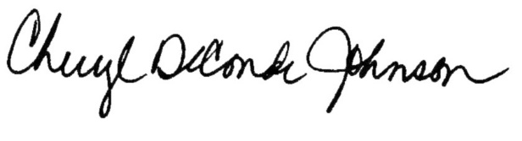

Cheryl DeConde Johnson, Ed.D.

Advocate

The ADEvantage consulting

Leadville, Colorado

cheryl@colorado.edu